Spray Content Uniformity Test

1. Introduction

In the pharmaceutical industry, spray dosage forms (such as nasal or oral sprays) are among the most complex drug delivery systems due to the need to ensure accurate and effective dosing with every actuation. One of the essential quality control tests for these products is the Spray Content Uniformity (SCU) Test.

2. Importance of the Test

This test aims to verify that each spray actuation delivers a consistent amount of active pharmaceutical ingredient (API) within acceptable limits. Ensuring uniform dosing is crucial for drug efficacy and patient safety, especially for medications with a narrow therapeutic index such as corticosteroids, antihistamines, and asthma medications.

3. Scientific Basis

The test is based on the principle of uniform distribution of the active ingredient in each delivered spray. Several physical and mechanical factors influence this distribution:

Homogeneity of the drug within the container (solution or suspension).

Consistency of internal pressure in the device.

Performance of the spray mechanism (valve, actuator, and nozzle design).

4. Test Procedure

According to pharmacopeias such as USP <601> and EP, the test is conducted as follows:

4.1 Required Materials and Instruments

HPLC (High-Performance Liquid Chromatography): Used to accurately quantify the active ingredient in each spray.

UV-Visible Spectrophotometer: An alternative to HPLC when applicable, for measuring absorbance of the API.

DUSA (Dosage Unit Sampling Apparatus): A specialized device for collecting individual spray actuations accurately.

Spray Actuator Device / Actuation Apparatus: A manual or automated system to standardize the spray actuation process.

Analytical Balance (±0.1 mg): Used for precise weighing of samples or extracted drug.

Glassware (Pipettes, Volumetric Flasks, Test Tubes): For solution preparation and dilution.

Vortex Mixer or Shaker: Ensures homogeneity of sample solutions before analysis.

Vacuum Pump or Compressed Air Source: Assists in controlled spray collection, especially with DUSA.

pH Meter (optional): May be used to monitor solution pH if required by the method.

4.2 General Procedure

1. Sample preparation: Shake the spray container to homogenize the content if needed.

2. Priming: Actuate several initial sprays to stabilize the system as per manufacturer instructions.

3. Spray Collection: Actuate and collect a defined number of sprays (typically 10) using the DUSA or other validated collection method.

4. Extraction and Dilution: Dissolve collected drug in a suitable solvent using volumetric flasks and vortex mixer.

5. Assay: Analyze the drug content in each collected spray using HPLC or UV-spectrophotometry.

6. Data Evaluation: Calculate mean content, relative standard deviation (RSD), and compare results to pharmacopeial specifications.

5. Guidelines and Acceptance Criteria

Acceptance criteria are defined by pharmacopoeial standards. In general:

6. Factors Affecting Spray Content Uniformity

Formulation Characteristics: Viscosity, solubility, and stability of the API.

Device Design: Valve and actuator construction, spray nozzle geometry, and consistency of the metering system.

Storage Conditions: Temperature and light exposure can affect drug stability and spray performance.

User Handling: Variability in patient technique may influence the delivered dose.

7. Challenges and Solutions

Settling of Suspensions: Use of effective suspending agents can enhance uniformity.

Spray Variability: Optimizing device design (e.g., nozzle diameter, valve type) can minimize inconsistencies.

Sampling Difficulties: DUSA or similar sampling systems with vacuum assist ensure accurate spray collection.

8. Conclusion

The Spray Content Uniformity Test is a critical part of quality assurance for spray-based drug products. Failure to achieve consistent dose delivery may result in therapeutic failure or adverse effects. Therefore, formulation strategies and device engineering must ensure reliable and uniform delivery, and testing must be conducted using validated and precise instrumentation.

9. Apparatus used in this test

1. HPLC (High-Performance Liquid Chromatography)

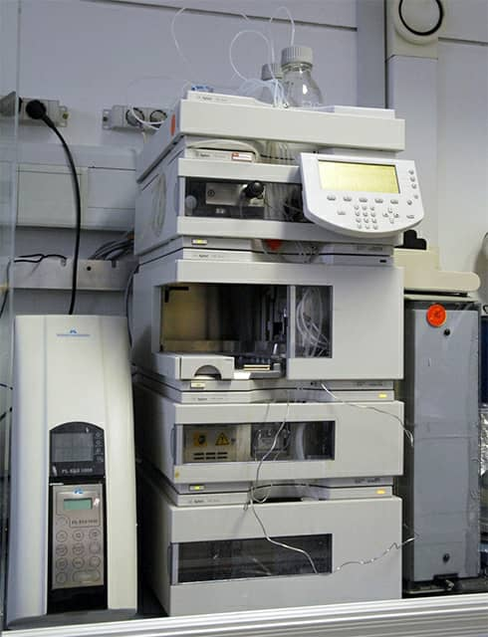

2. Vortex Mixer or Ultrasonic Bath:

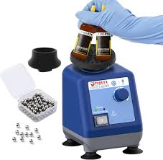

3. Analytical Balance:

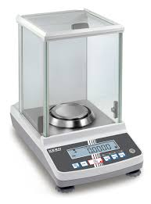

4. UV-Visible Spectrophotometer:

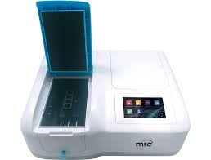

5. Glassware (Volumetric flasks, Pipettes, Beakers):

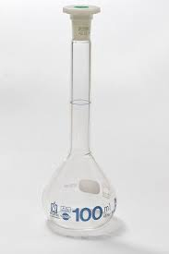

10. References

1. United States Pharmacopeia (USP) <601> – Aerosols, Nasal Sprays, Metered-Dose Inhalers, and Dry Powder Inhalers.

2. European Pharmacopoeia.

3. Aulton’s Pharmaceutics – The Design and Manufacture of Medicines.

4. Pharmaceutical Aerosol Technology – Hickey, A.

5. FDA Guidance for Industry: Nasal Spray and Inhalation Solution, Suspension, and Spray Drug Products.